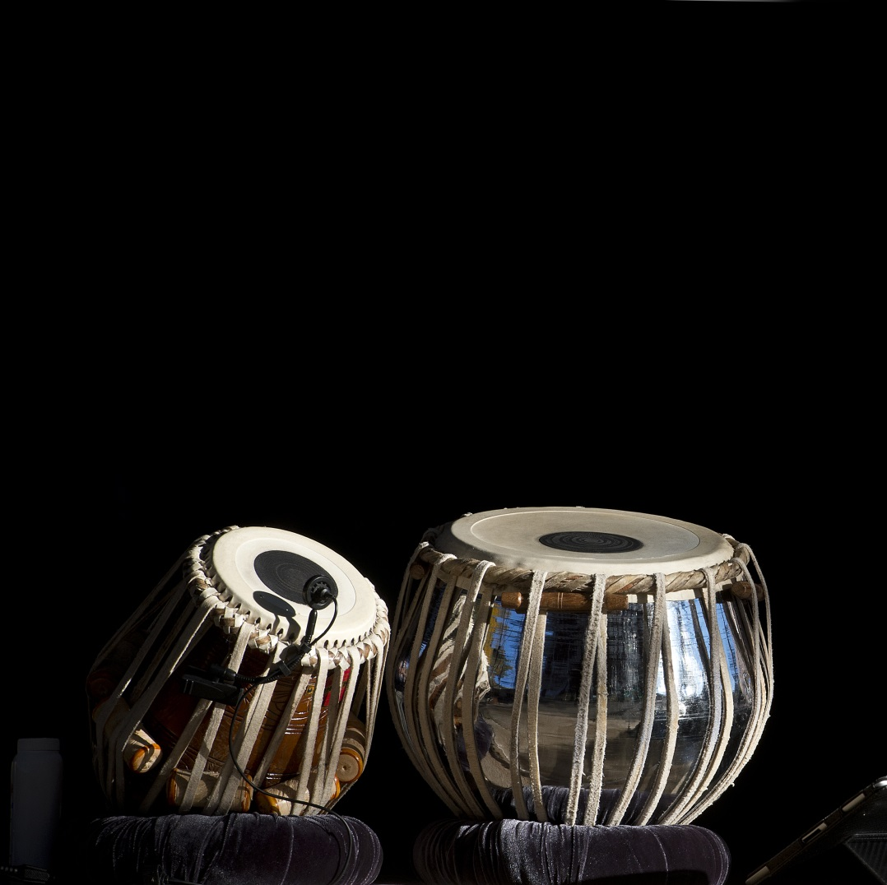

RBU ,B.T.ROAD,MAIN CAMPUS,KOLKATA

RABINDRA BHARATI UNIVERSITY



NAME : DEYA MUKHERJEE

COURSE : GEC-2.1

SUBJECT : PERCUSSION(TABLA)

ROLL : BAHVMU/21-22/0011

DEPT : VOCAL MUSIC

YEAR : 2021-2022